The Mayan Civilisation Knowledge Organiser: Key Learning:
1. The Mayans- When and where did they live? (timeline, map and society.)  2. City states- buildings, rulers and trade.  3. Mayan food and fashion.  4. Mayan numbers and writing (including calendar.)  5. Mayan religion and gods. | 6. What happened to the Mayans and how do we know all this?  CCL: Designing Mayan Masks (Art/D&T)  Make a Mayan Temple (D&T)  Rainforests (Geog)  Text: Middleworld by J&P Voelkel (DR)  Visit: London Aquarium -rainforests.

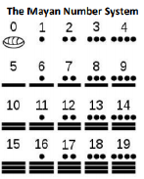
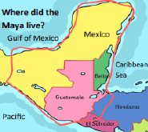
The Temple at Chichen Itza

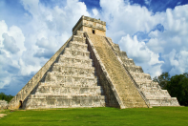
Timeline | Masks:  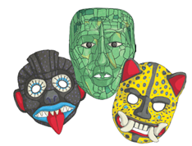  Gods:  Ancient Mayans  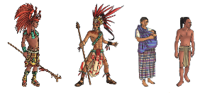  Cacao vs corn / maize | Key Vocab
  Itzamna  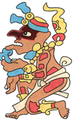 | Ix Chel  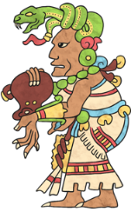
  Chac  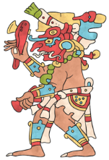 | Kimi  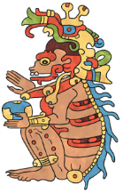
  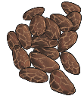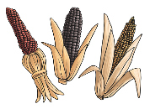
2000 BC – Farming villages appear.  1000 BC – Larger settlements are created.  600 BC – Farming develops, and cities grow in size with more food available.  700 BC – Maya writing begins developing.  400 BC – First Maya calendars are carved into stone.  300 BC Mayans begin to be ruled by kings. Large cities are built.  100 BC – First pyramids are built.  400 AD – Many people live in a capital city.  0-900 AD - City states rise and fall, many fighting each other, and others abandoned such as Teotihuacan, Tikal and Caracol.  925 AD – Chichen Itza becomes capital city.  1517 AD – The Spanish arrive and begin their colonisation of Central America. Disease and war virtually killed off ancient Maya...  2021 AD – Modern Mayans still live in Mesoamerica and keep some of the old traditions and ways (including food and drink inspired by Ancient Maya.) |  | Artefact: An object that is made by a person, such as a tool or a decoration, especially one that is of historical interest.  Calendar: A printed table showing all the days, weeks and months of the year.  Civilisation: Human society which is organised.  Cocao (bean): Fragrant beans that chocolate is made from.  Dynasty: A series of rulers or leaders who are all from the same family, or a period when a country is ruled by them.  Empire: A group of countries ruled by a single person, government or country.  Hieroglyphics: A system of writing using pictures not words:  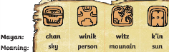  Kingdom: A place ruled by a king, queen or important person.  Maize: Also known as corn, is a cereal grain, a staple of the Mayan people.  Pyramid: Huge structures usually with a temple on top.  Prediction: A statement about what you think will happen in the future.  Temple: A building used for the worship of a god or gods in some religions.  Tomb: A large stone structure or underground room where someone, especially an important person, is buried.  Worship: To have or show respect and admiration for a god or goddess.

